

|  |
| --- |
| **AADC Manual** |
| 01.05.2021 |

Inhaltsverzeichnis des Leitfadens

Abbildungsverzeichnis 4

Tabellenverzeichnis 5

1 Introduction 6

1.1 Introduction 6

1.2 Tips for Readers 6

2 Hardware Description 6

2.1 Schematic Diagram 6

2.2 Computer 6

2.3 Graphics Card 7

2.4 Arduino Microcontroller 7

2.5 Sensors 7

2.6 Cameras 7

2.7 Power System 7

2.7.1 External power unit 7

2.7.2 Battery (2S) for powertrain units 7

2.7.3 Battery (6S) for measurement units 7

2.7.4 Charging of Batteries 7

3 Software Description 7

3.1 Operate System 7

3.2 ADTF 7

3.3 Qt Creator 7

3.4 AADC Plugin Documentation 7

3.5 OptIlmDriveX Plugin 7

3.6 Template Plugin 7

3.6.1 How to program a plugin 7

3.7 Jury Communication 7

4 Experiment Guide 7

4.1 Requirements & Attentions 7

4.2 Experimental Procedure 7

5 Problems & Solutions 7

5.1 Problems of Hardware 7

5.2 Problems of Software 8

5.3 Extra Problems 8

# Abbildungsverzeichnis

Figure 1: Schematic diagram 5

# Tabellenverzeichnis

Es konnten keine Einträge für ein Abbildungsverzeichnis gefunden werden.

# Introduction

## Introduction

Here write the introduction of AADC and OptIlmDriveX.

## Tips for Readers

# Hardware Description

## Schematic Diagram

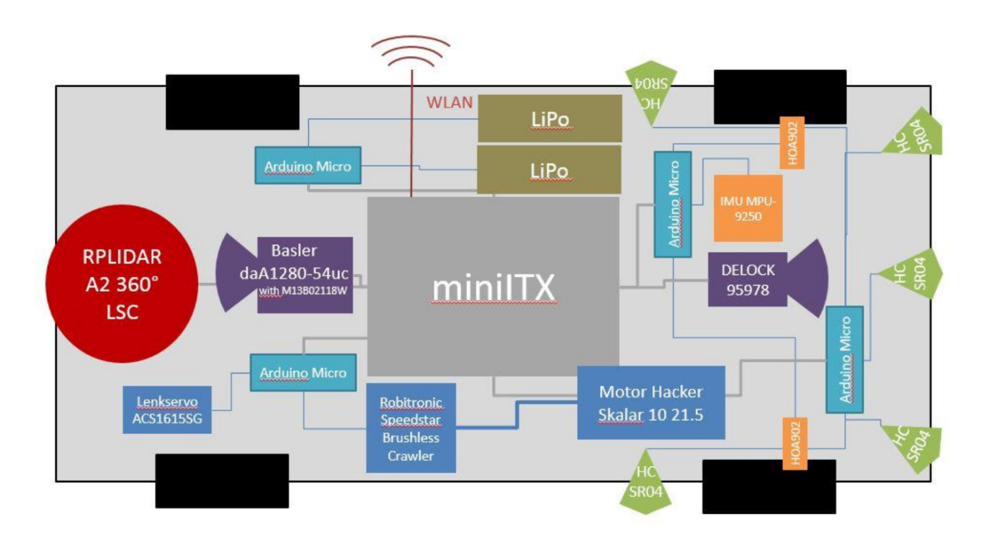

Figure 1: Schematic diagram

## Computer

[hier](https://sharepoint.tu-ilmenau.de/websites/dokumente/Printmedien/)[1]

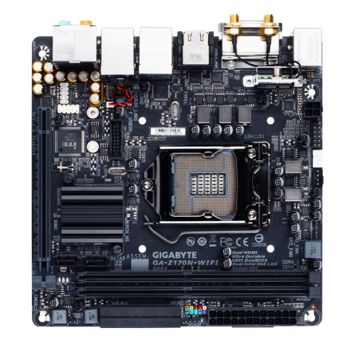

* Format: Mini-ITX
* Chipset: Intel® Z170
* Socket: 1151 for 6th generation Intel® CPUs ("Skylake")
* CPU: Intel® Core i3-6100T CPU (3.2 GHz)
* RAM: 2× 8 GB DDR4 in Dual-Channel
* Slots (physical): o 1× PCIe 3.0 x16 o 1× WiFi-/Bluetooth Module (incl. 802.11ac)
* GPU[2]: GeForce GTX1050Ti
* Internal Connectors:
* 6× SATA 6G
* 1× M.2 (PCIe 3.0 x4)
* 2× USB 3.0 (one header)
* 2× USB 2.0 (one header)
* 1× Fan (4-Pin PWM
* Power/Reset/LED/Front-Audio
* External Connectors:
* 1× PS/2 Keyboard/Mouse
* 4× USB 3.0 o 2 x Intel® GbE LAN chips (10/100/1000 Mbit)
* Wi-Fi 802.11 a/b/g/n/ac, supporting 2.4/5 GHz Dual-Band
* 2× WiFi Antenna (in bundle)
* 2× HDMI 1.4b
* 1× DVI o 1× S/PDIF (optical)
* 5× Audio (7.1 Realtek ALC1150)

## Arduino Microcontroller

## Sensors

## Cameras

## Power System

### External power unit

### Battery (2S) for powertrain units

### Battery (6S) for measurement units

### Charging of Batteries

# Software Description

## Operate System

## ADTF

### ADTF Basic

#### ADTF License

Each vehicle is delivered with one valid ADTF License file. It is located in

/home/aadc/License/

#### ADTF Manual Documentation

The ADTF3 Manual is located at:

[ADTF3 Guides (digitalwerk.net)](https://support.digitalwerk.net/adtf/v3/guides/)

#### AADC ADTF Source Package

The Source Package provides a lot of standard functionalities to use the vehicle, meaning how to read its sensors, control its actuators and understand the conditions of the competition. The Source Package contains many different ADTF Filters in three categories: 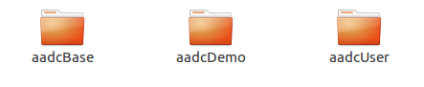

* AADC Base Filters

The filters in AADC Base serve their users mainly as the standard communication with the Arduinos. The teams must not modify these filters. If any question or errors occur, refer to the website forum and the described procedure in the regulations.

* AADC Demo Filters

The filters in AADC Demo offer an extended scope of functionalities for the use of the vehicle. The package contains filters to visualize sensor values, to do calibration procedures, to convert values or several ways to control the speed and steering controllers of the car. All these filters can be modified by the teams or can be used as a start-up for their own algorithms and implementations.

* AADC User Filters

The AADC User Filter package contains one template filter without any specific functions. All the individual filters of the OptIlmDriveX have to be placed in this package and its corresponding directory.

**Notes:**

All the three categories in the source package have a prepared build environment including a complete CMake-Project. A lot of useful information can be found also in the ADTF SDK [ADTF: ADTF 3 - Automotive Data and Time-Triggered Framework (digitalwerk.net)](https://support.digitalwerk.net/adtf/v3/adtf_html/index.html).

### ADTF Projects and Sessions

The Home View

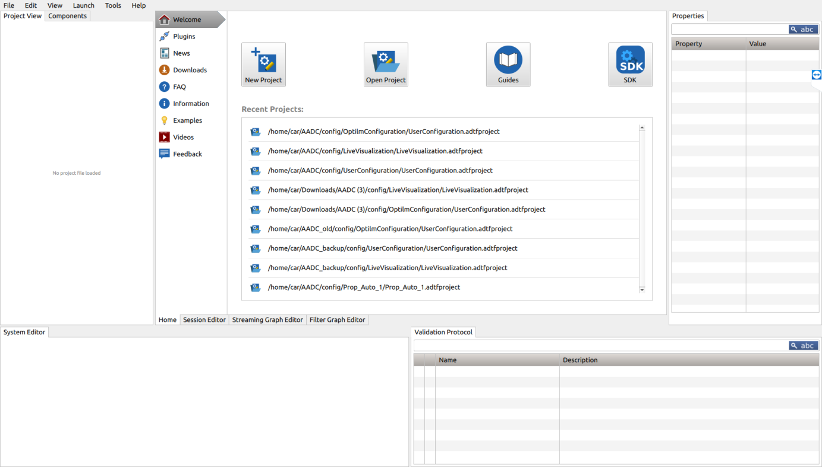

In this page you could quickly create open a project. The Left navigation bar provides some default actions linking to additional information which can be adapted in your cesettings file (see Settings Editor (Options)).

The Project View

The main files that make up a project are session files, graph files and system files.

The Component View

These are the elements that can be added to the filter graph by drag and drop actions.

Note: Streaming Graph and Filter Graph accept different Components. So the set of displayed elements in the Components View change accordingly to the selected graph tab ("Streaming Graph Editor" or "Filter Graph Editor")

Editors



* Session Editor

A project maybe contains a lot of streaming graph, filter graph and system definitions, but as soon as we want to run a certain combination of it with the help of the ADTF launcher things must be clearly defined. The session defines what system should be loaded, which streaming graph should act as data source and data sink and what filter graph should manipulate the data.

How to add new sessions please see: How to add a new session to project.

* Streaming Graph Editor

Data must either be generated somehow or a kind of data source must be plugged in to get data into the ADTF system. On the other side data is consumed by someone or must leave the ADTF system through some kind of data sink. This is what the streaming graph is good for. Developers use the SDK to write their own sources and sinks. To let data flow between two elements place a Sample Stream between them and connect the pins by drawing a line. Follow this link for more information about streaming graphs.

Data transfer from the **Streaming Graph** to the **Filter Graph** begins with a **Sample Stream (component)** placed on the Filter Graph Dock and continuous on the Filter Graph level with a Streaming In-port. The connection is created automatically but only if the name of Sample Stream and Streaming In-port are exactly the same.

Filter Graph Editor

The filter graph is where the data manipulation and data analysis takes place. Data comes from the streaming graph through Streaming In-ports and leaves the filter graph through Streaming Out-ports. Both types can be added through the context menu of the Graph Editor. It is important to mention that the name of the Streaming Port and the name of the Sample Stream in the connected Streaming Graph are the same. Follow this link for more information about filter graphs.

Data transfer from the **Filter Graph** to the **Streaming Graph** goes through a Streaming Out-port on the Filter Graph level and continuous with a Sample Stream on Streaming Graph level, placed on the Filter Graph Dock. The connection is created automatically but only if the name of the Streaming Out-port and the Sample Stream are exactly the same.

System Editor

Double clicking a system file in the Project View opens it inside the System Editor. If your session incorporates filters, sources or sinks that have dependencies to libraries outside of ADTF this is the right place to define them.

Details please see AADC_Manual/adtf_3.6_guides/tools_adtf_configuration_editor.html

### How to add a new session to project

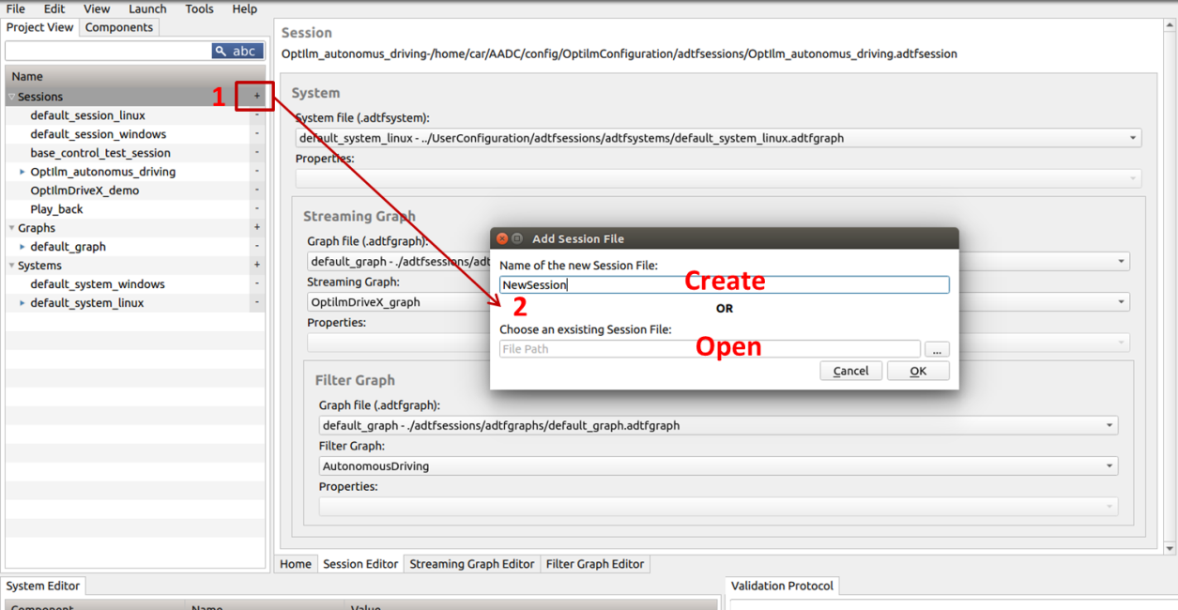

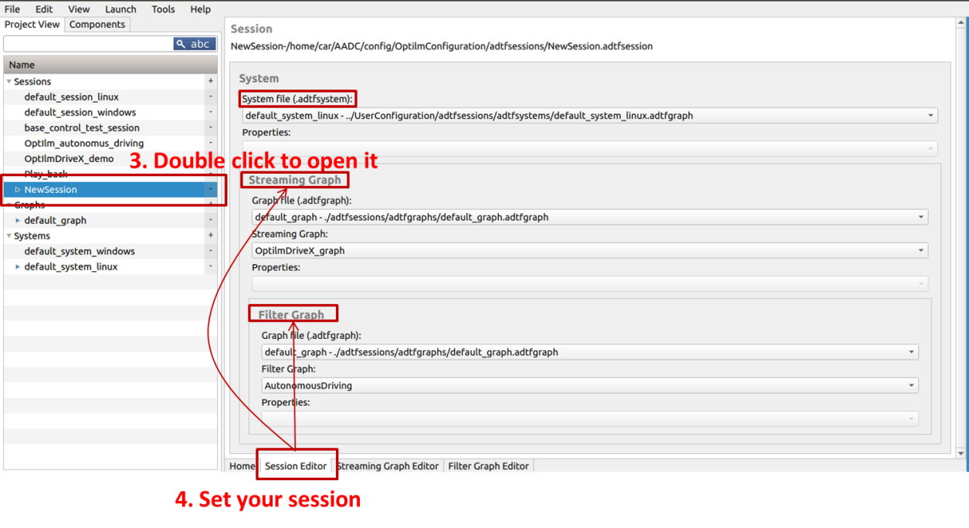

By setting your session, you may need to create new Streaming Graph and Filter Graph. These could be done with follow steps:

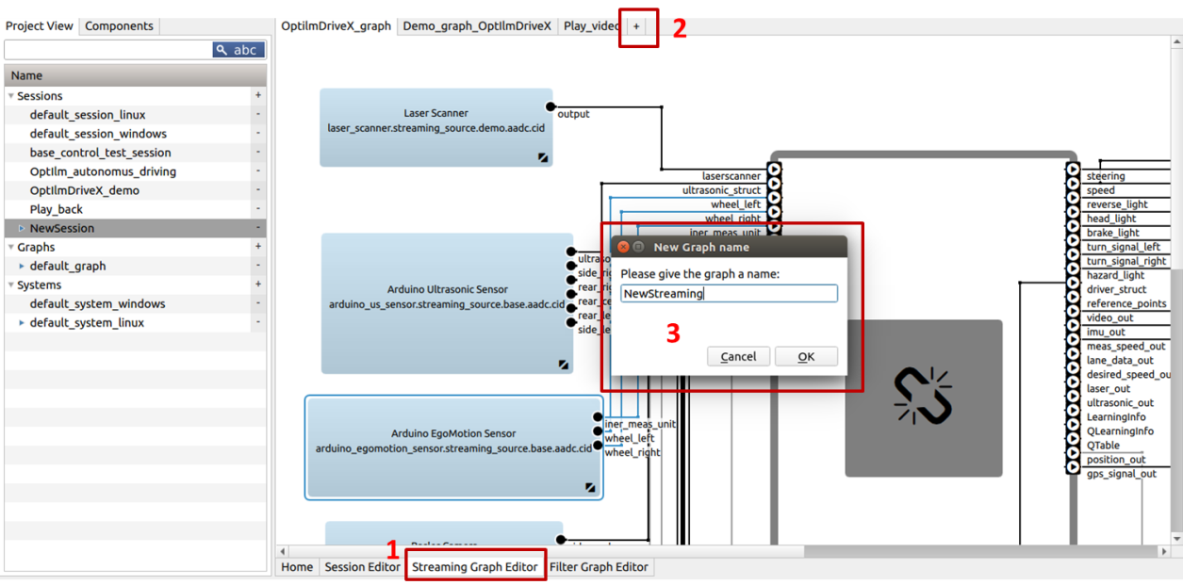

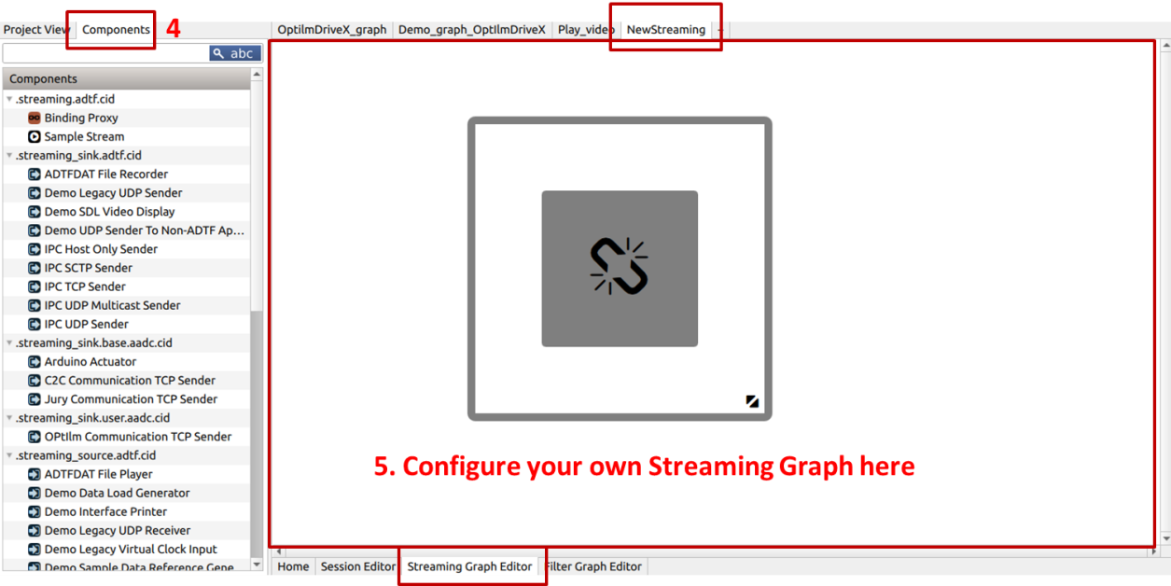

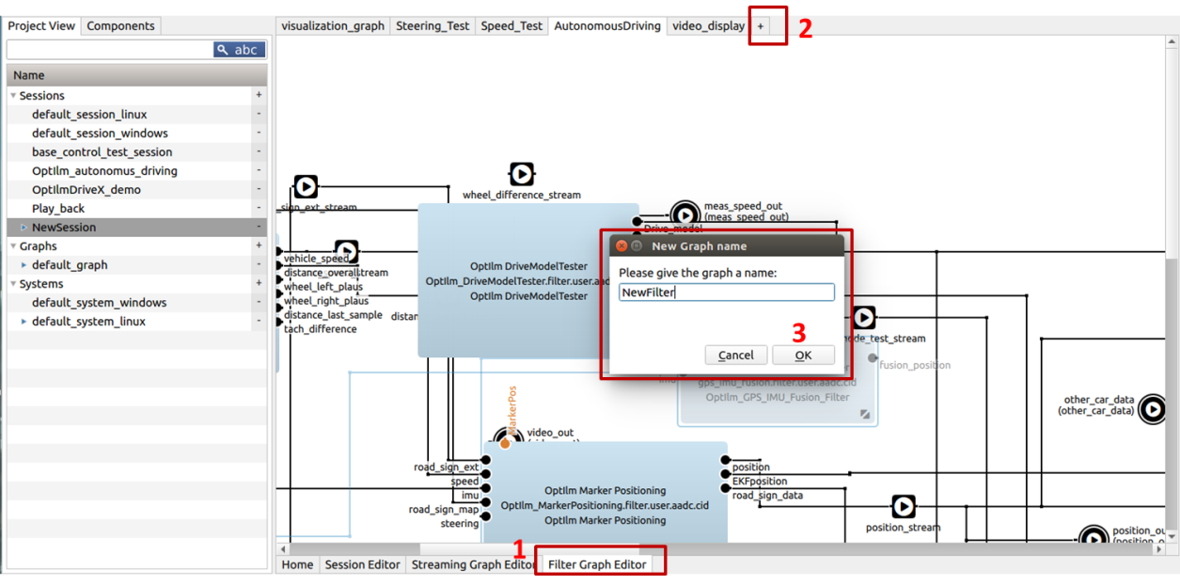

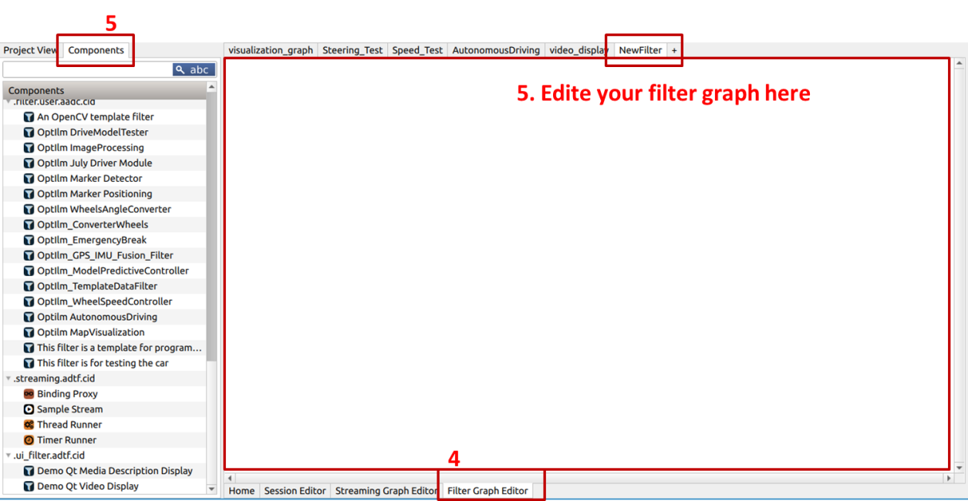

## Qt Creator

## AADC Plugin Documentation

## OptIlmDriveX Plugin

### How to add a filter graph

For a quicker understanding and using for beginner, we programed a template filter with necessary functions to help you complete your project. It could be found here:

-----Link from Git

### How to program a plugin

## Jury Communication

# Experiment Guide

## Requirements & Attention

Please read the following precautions carefully before the experiment:

* When a **new colleague** is not familiar with the operation process, please ensure that **a skilled colleague is present** before conducting the experiment.
* Please keep the car **on the shelf**, except driving. The car is placed on the shelf in the following way. Make sure the shelf and chassis **are positioned correctly**.
* Please keep the car on the shelf when debugging the code.
* When driving, please always pay attention to the position of the car, **handle in hand**, when the car deviates from the lane or other **emergencies**, please **manually brake**.
* When connecting the battery, please connect the **control wire (thin wire) first**, then the power wire (thick wire).
* Please keep the motor **off**, except driving.
* When the computer is turned off, please **restore the ON/OFF buttons** of the computer and motor to the OFF position manually.

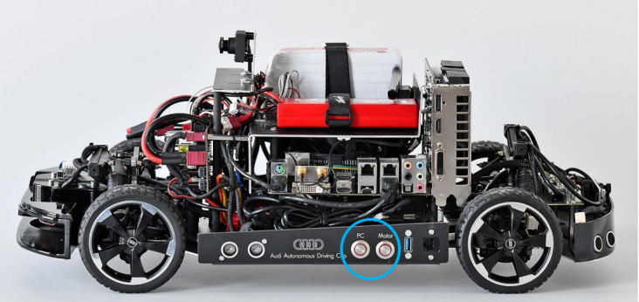

## Experimental Procedure

1. Push the experimental equipment to the designated position
2. Position the marker referring the map.
3. Turn on the computer of the car and the laptop.
4. Open the project in ADTF.

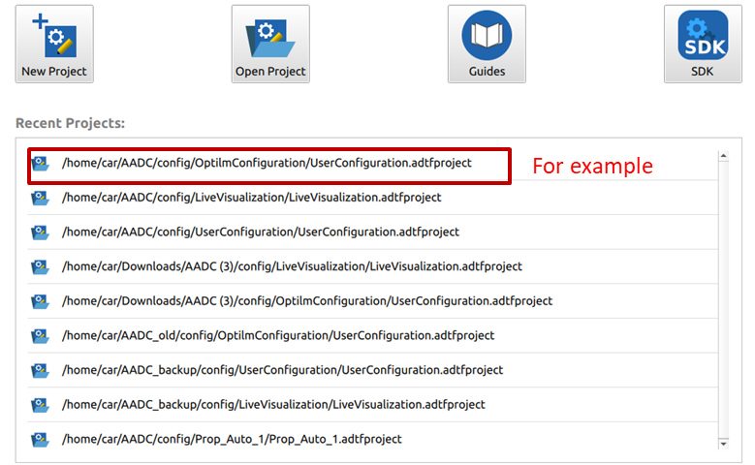

1. Put the car in the right place.
2. Right click your session and launch it with GUI control.

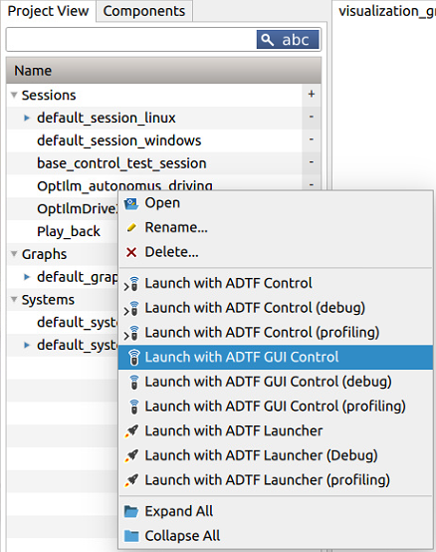

1. Initialize the session. Run the session.

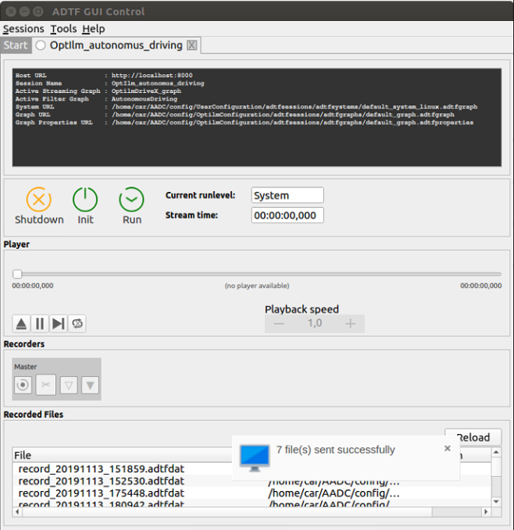 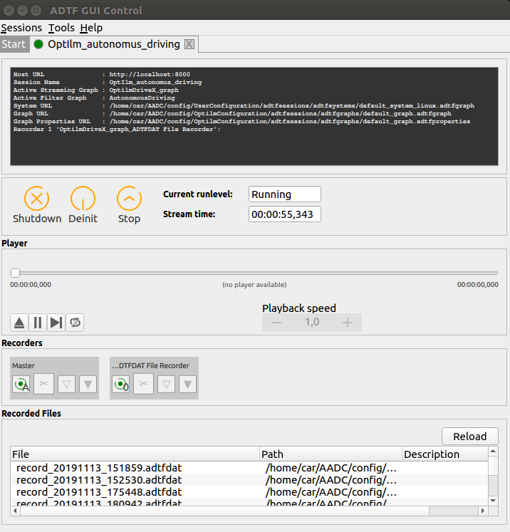

1. Check camera, lidar and other log info with no abnormity.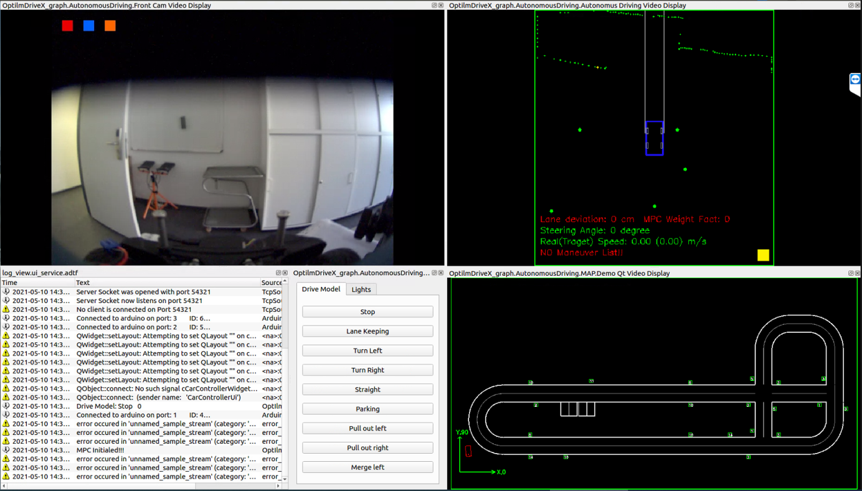
2. Check handler by moving the trigger and the steering wheel. Figure out who is controlling the car, handle or computer.
3. Open Jury.

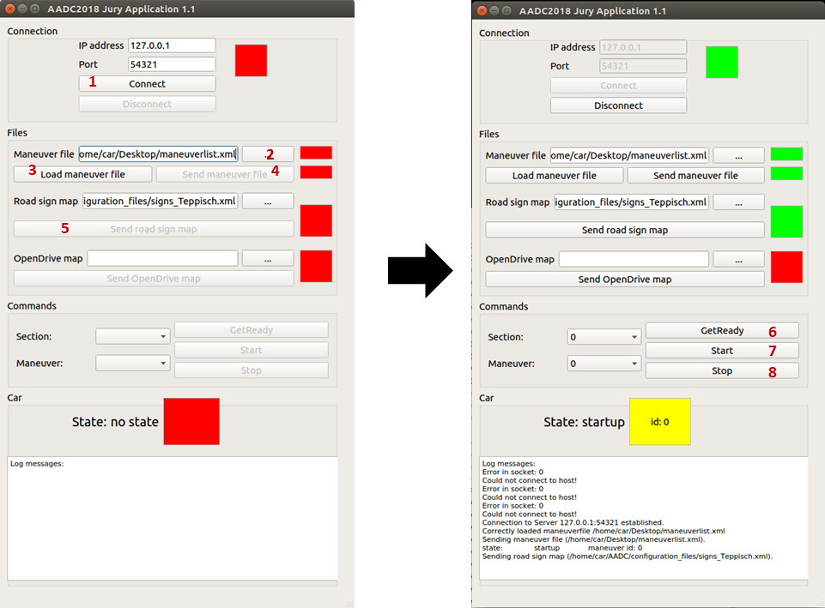

Attention: After driving please click Stop button by step 8.

1. Do your experiments.
2. **After Experiments, Please shut down the computer; restore the ON/OFF buttons of the computer and motor to the OFF position manually; put the car on the shelf and then place them on the desk. Please ensure the car is placed on the shelf in the right way.**

## Record Data

Data recording is necessary for experiment and code debugging. If the active streaming graph has ADTFDAT Recorder, then it’s possible to record the data passed to Recorder by running your session. In this section how to record data into ADTFDAT file with ADTF GUI Control and how to export ‘.datfdat’ file into excel with ADTF DAT Tool GUI will be introduced.

If the currently active streaming graph (referenced in the running session) has more than one ADTFDAT File Recorder each recorder gets it own control. Additionally one master control is added for convenience which drives all other recorders. The Recorder serves these functionalities:

1. Start recording
2. Stop recording
3. Split recording
4. Open marker dialog
5. Add QuickMarker

A red button means recording a green button means ready to start recording. The recorded data goes into a DAT file. The DAT files can be split into several chunks by clicking the split button. The given name to a recoreded file is configured as property of the ADTFDAT File Recorder inside the Configuration Editor.

### Marker

The GUI-Control offers two possibilities to mark important events during recording. On the one hand you can use Quick Markers to place a marker immediately with a default label and the current time. On the other hand you can use the marker dialog button to specify a name and adjust the timestamp.

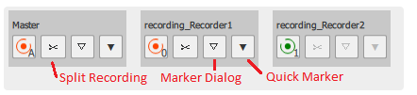

****Quick Marker****

Click the Quick Marker button and a marker is set immediatly at the current stream time with the default marker name

****Marker** **Dialog****

1. Click marker dialog button  
   Marker dialog will open. 'Name' is set to default marker name. 'Position' is set to current stream time.   
     
   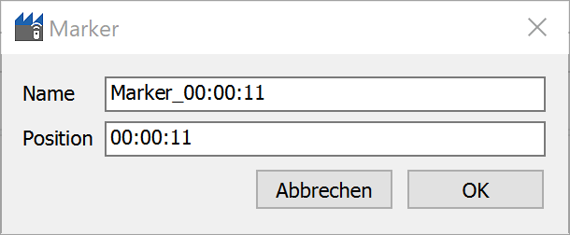
2. Marker Dialog
3. If necessary, change marker name
4. If necessary, adjust marker position  
   Accepted pattern: [hhh:]mm:ss  
   For example:
   * 01:12:34
   * 1:12:34
   * 100:00:00
   * 23:42
5. Click 'OK' Button  
   Marker dialog will close and marker is set in DAT file.

Short Cuts

[ctrl + 0 ] sets a QuickMarker for all recorders, note it is zero not the character 'O'

[ctrl + m ] opens the marker dialog for all recorders

### Recorded Files Path

The recorded files could be found here (default):

### Export ADTFDAT File into Excel

ADTF DAT GUI provides the possibility to export ADTFDAT file into csv file.

* Run {Dir/}adtf_dattool_gui.exe
* Add adtfdat file.

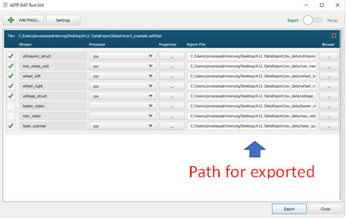

* Select which data you want to export.
* Configure the export path.
* Export.

Common problem：There are no available options of processor.

Solution: activate path setting.

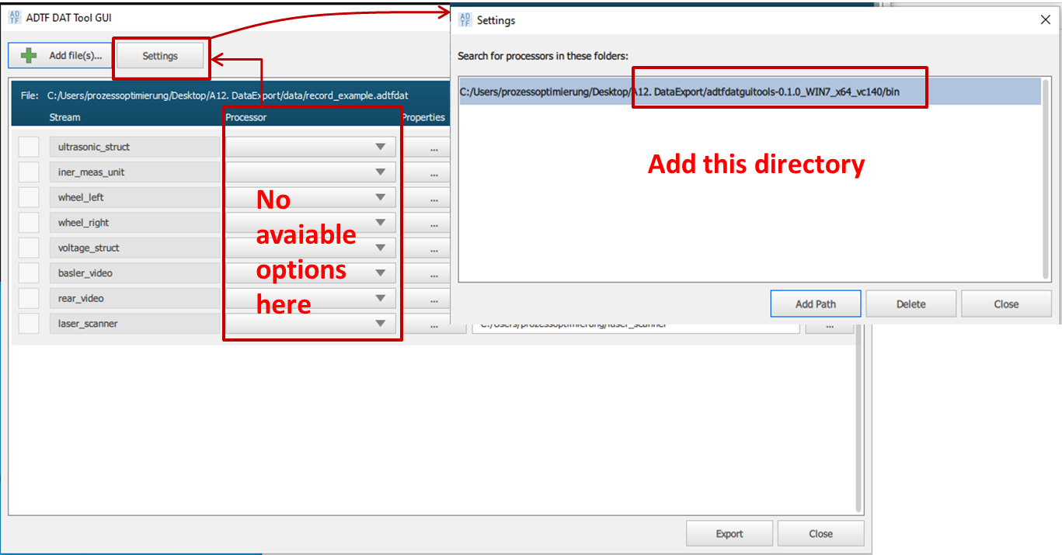

* Import data to excel.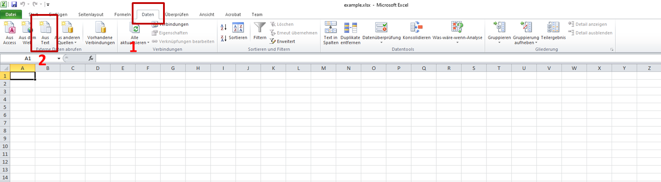

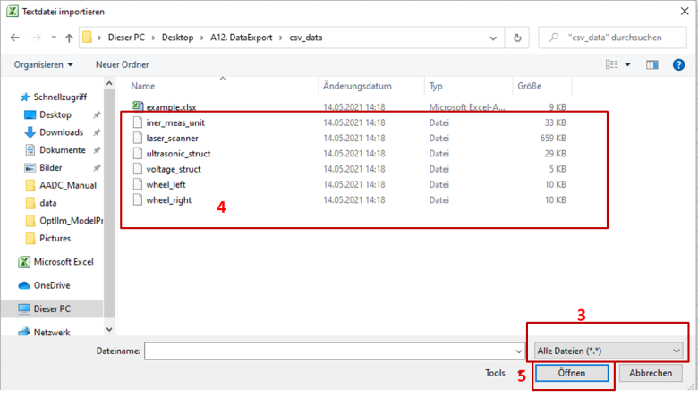

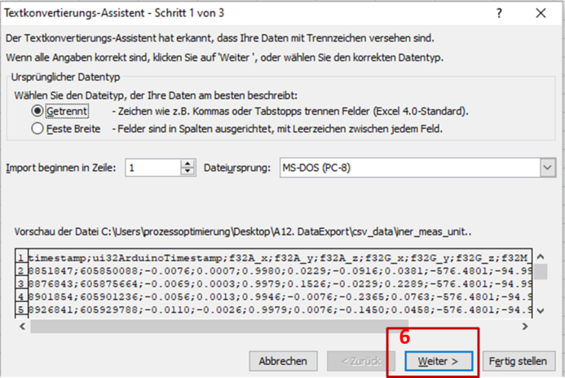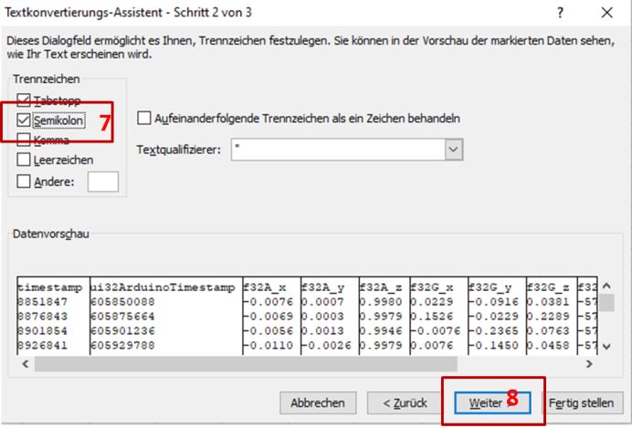

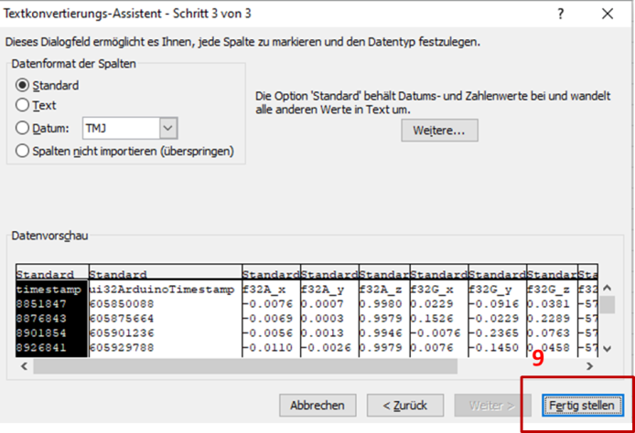 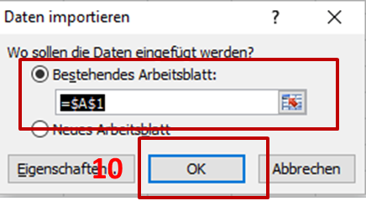

Imported data like:

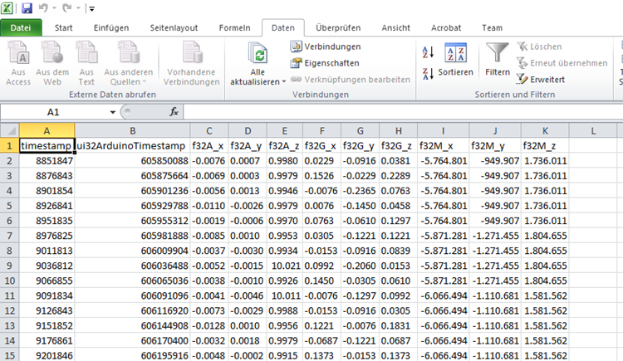

# Problems & Solutions

## Problems of Hardware

1. The battery low-voltage alarm is on:

* Drive the car back to the operator's desk and connect the power supply. Change the battery. PS: Disconnect the control cable first and then the power cable.

1. Motor controller doesn’t react:

* Switch the control to handler.
* Check the motor switch is on.
* Check the power cable and control cable connection.
* Check if the fuse burned out.
* Check the mechanical issue.

1. Camera signal not available:

* Check the USB connection. The probability is that the interface is loose.
* Check the filter of camera in ADTF editor. Ensure the camera signal is finally sent to __________.

1. Calibration of front (steering) wheels:

* Rotate the knob shown in the figure.

1. Arduino sensors return wrong signal value or value with large error.

* Reset Arduino microcontroller.
* 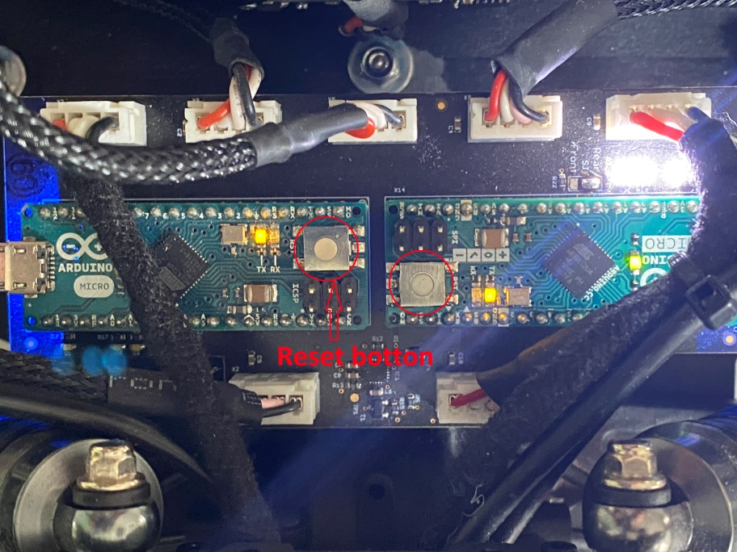

## Problems of Software

1. Launching failed:

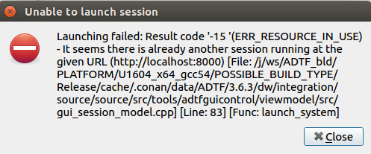

This error occurs, because another session is running. Only one session could be launched at the same time.

1. ADTF GUI or ADTF editor flashing back:

* If everything runs properly before that, then it could be BUGs of ADTF software. Reopen it and try again.
* If you have changed something before flashing back. Then it could be problems of your code or configuration. Check what you have done and please make sure memory configuration and threading are all right.
* A common problem comes from memory allocation. After definition of a global structure pointer, you need to allocate memory for the pointer in Configure or Initial functions. Otherwise the ADTF will flash back, but you won’t get error by build process in Qt Creator.
* PS: Generally speaking the software error won’t break hardware. But high temperature due to overloaded or long-term running may destroy the mainboard.

1. No reaction after clicking Init-button or Run-button of ADTF-GUI control:

* Close the terminal console of GUI control and try to open it again.

1. Error in ADTF: Input or output pins are not described.

* Check the corresponding code in Configure function or functions with other flexible names defining the pins.

## Extra Problems

1. URL: https://sharepoint.tu-ilmenau.de/websites/dokumente/Printmedien/ (Aufrufdatum: 19.02.2020)
2. URL: [Grafikkarten der GeForce 10-Serie (nvidia.com)](https://www.nvidia.com/de-de/geforce/10-series/) (Aufrufdatum: 14.05.2021)